

Hypermedia Applications a.y. 2018/19

Design document 04/07/19

<https://bookhub-ctm.herokuapp.com/>

**Alessandro Carughi – alessandro.carughi@mail.polimi.it**

**Luca Maltagliati – luca.maltagliati@mail.polimi.it**

**Marco Turetta – marco3.turetta@mail.polimi.it**

**Abstract**

The following document aims at resuming the work done during the preliminary design phase of the project of the Hypermedia Applications course.

The main goal of the project is to ease the purchase of books with the functionalities provided by the e-commerce. Another important objective that the project fulfill is to provide users a friendly interface to select new readings via the filters implemented. In addition, the possibility of reviewing books should raise the proactivity of the users towards a creation of a community.

In the following, we report the work executed in each step of the design process. In particular:

* **Graphical Representation: For the design in the large, where we used the Interactive Dialogue Model for the planning of the content architecture of the web-site, we have included the C-IDM and L-IDM schemas along with some textual descriptions;**
* **For the scenarios ideation, the textual description of three possible use cases of our application;**
* **For the design in the small, the textual description of the requirements of the pages involved in our scenarios along with their graphical representation;**
* **For the database design, the ER schema and logical model.**

**Graphical Representation**

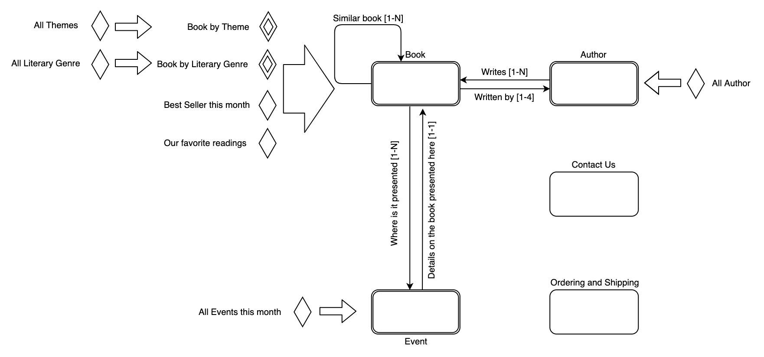C-IDM

Diagram 1 - C-IDM

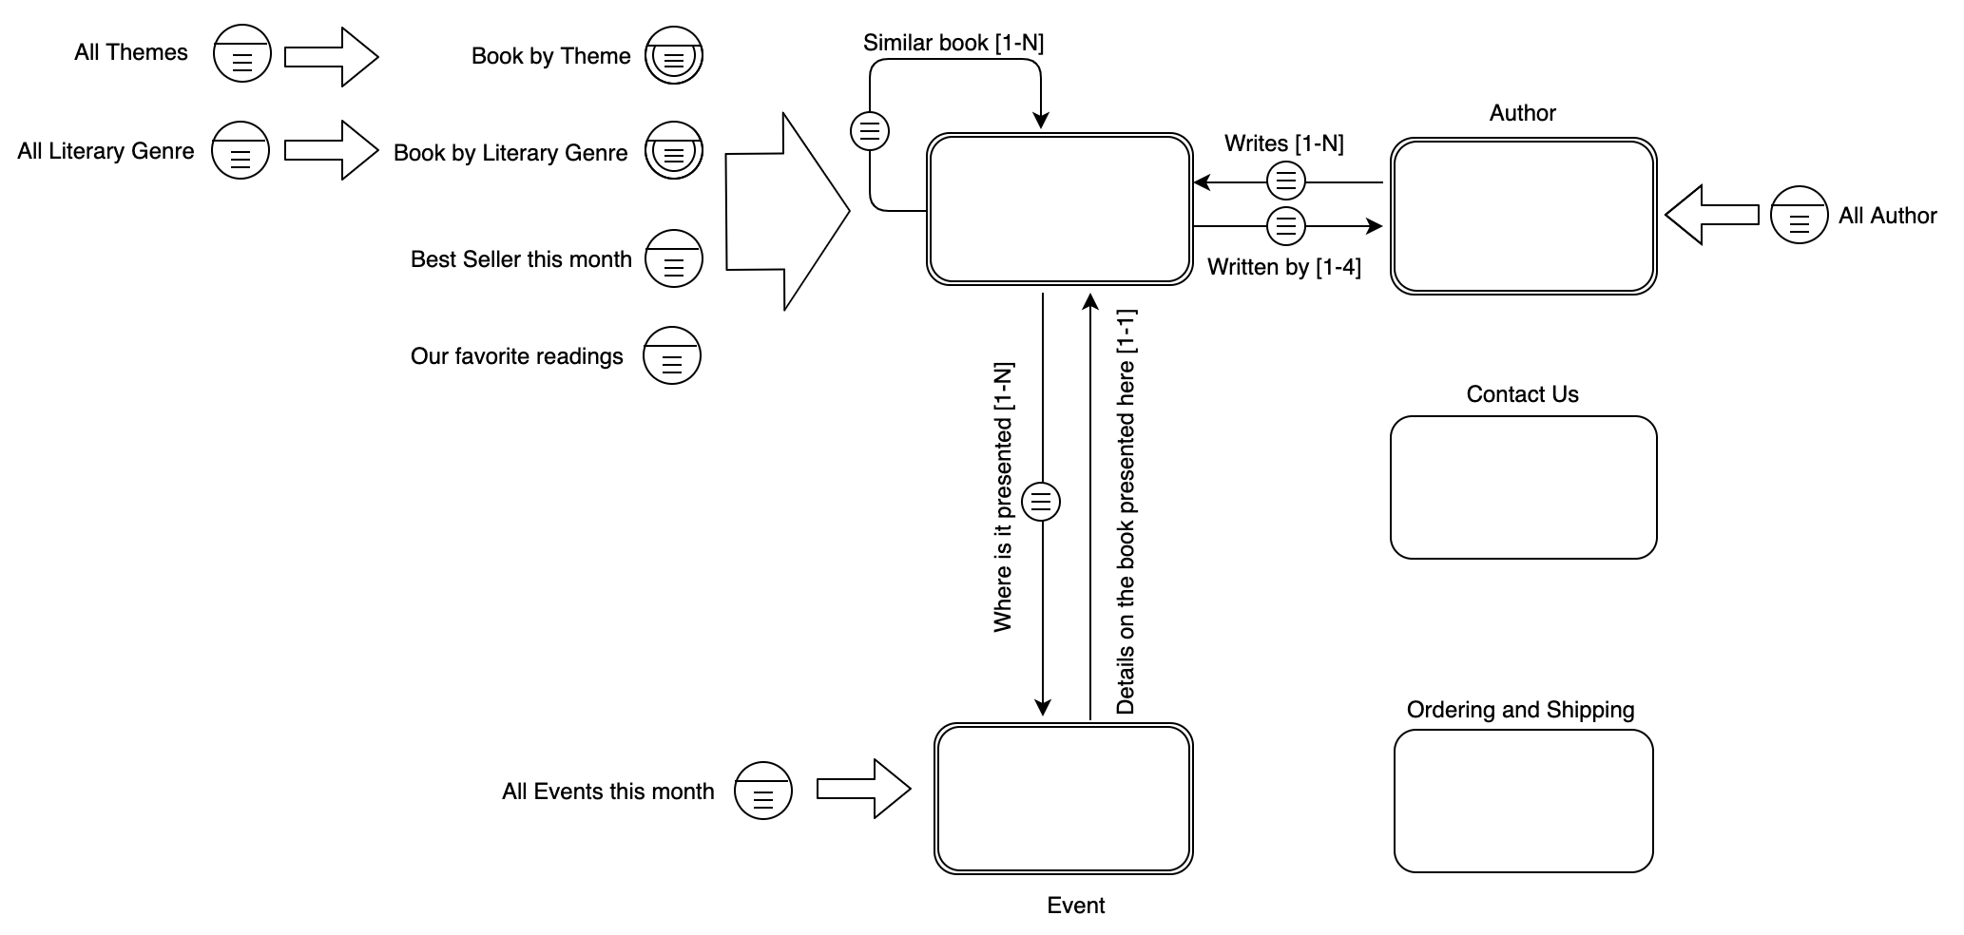L-IDM

* Name
* Surname
* Biography
* Picture

Genre

* Email
* Phone
* Address
* Location
* Book
* Date
* Title
* Author
* Themes
* Literary Genre
* Picture
* Items
* Address
* Date

Diagram 2 - L-IDM

**Scenarios**

**Scenario 1:** Alessandro is in a library and sees a book that he wants to buy. Unluckily, there are no more copies. Thus, he visits the website BookHub and searches the name of the book. When the book appears on the page, he clicks on it and then the information of the book is shown.  
Now he can read the reviews and, if satisfied, add to the cart and then buy that book.

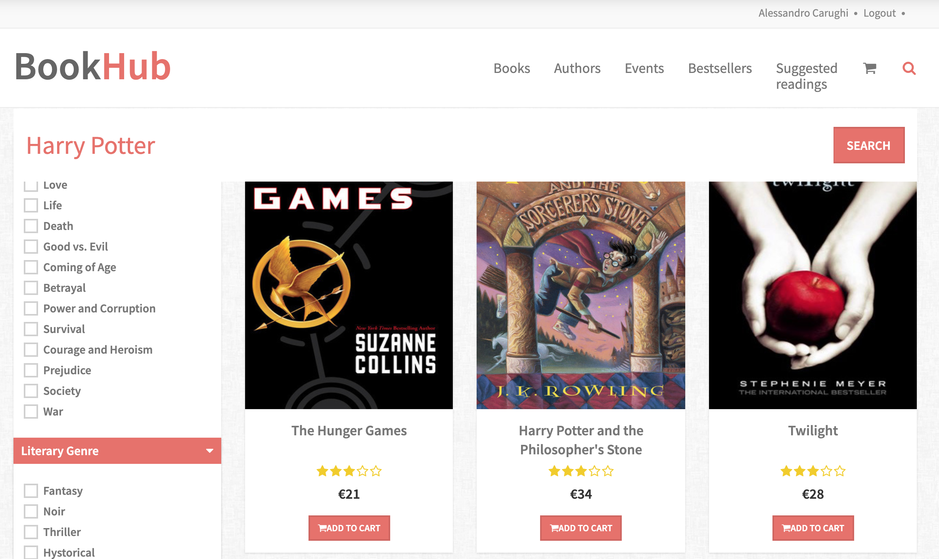

Search bar

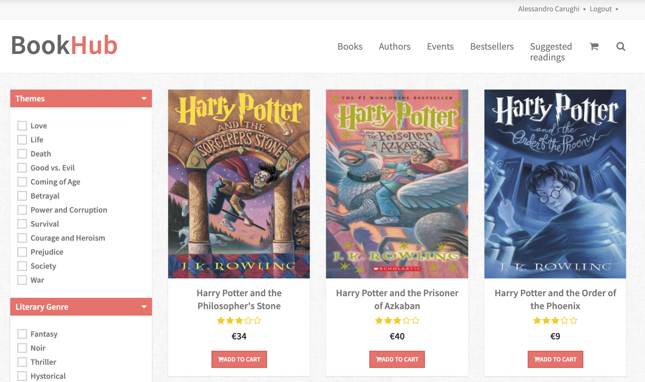

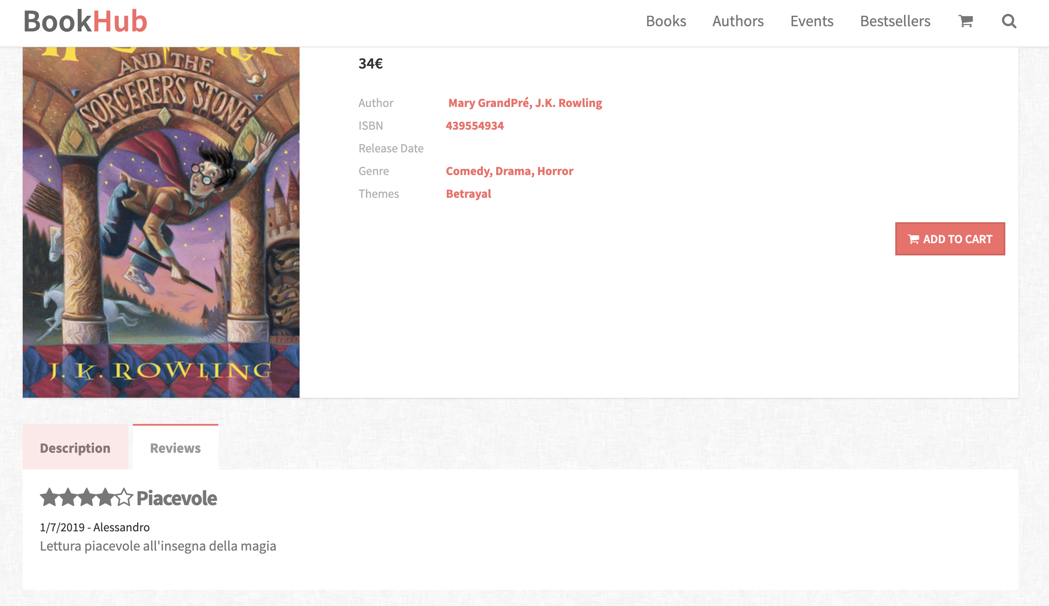

Review space

To buy

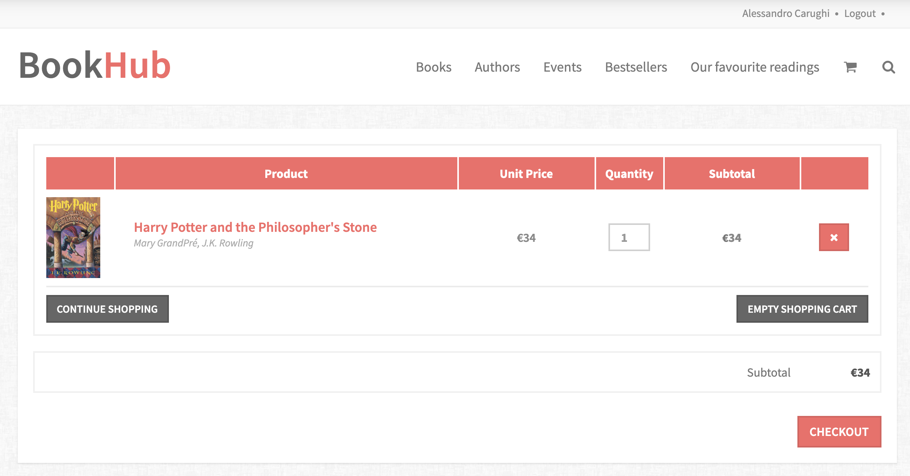

**Scenario 2:** Luca has a favorite author and he want to read one of its work.  
So, he decides to open the website to search his favorite author.  
Once the search is submitted, the page of author is showed and after its biography Luca can see all the works of the author.

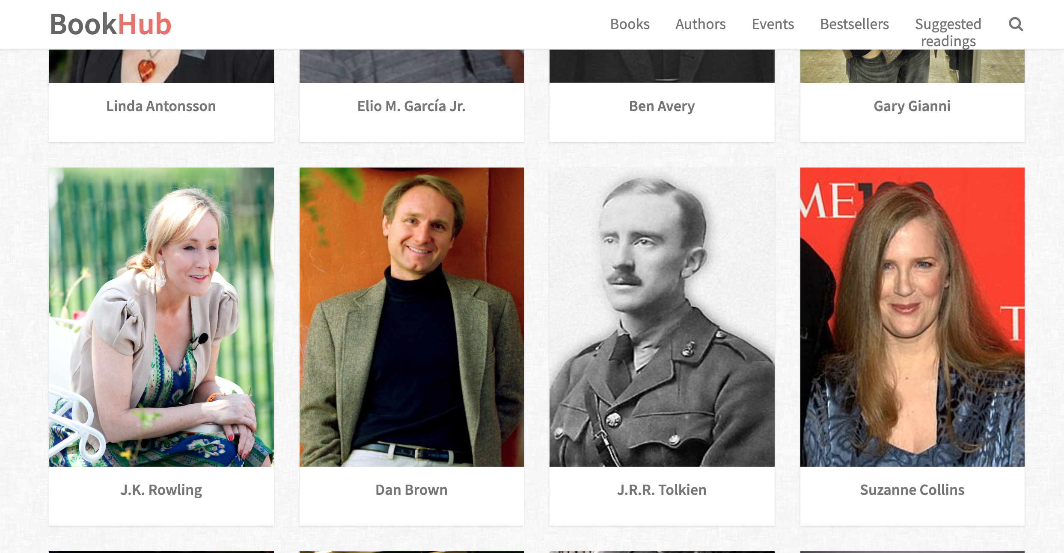

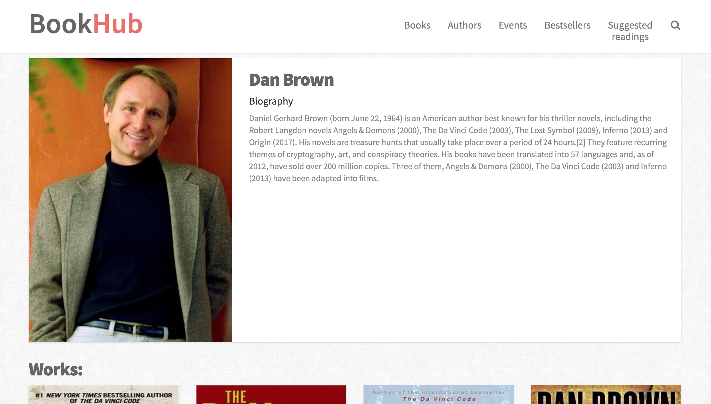

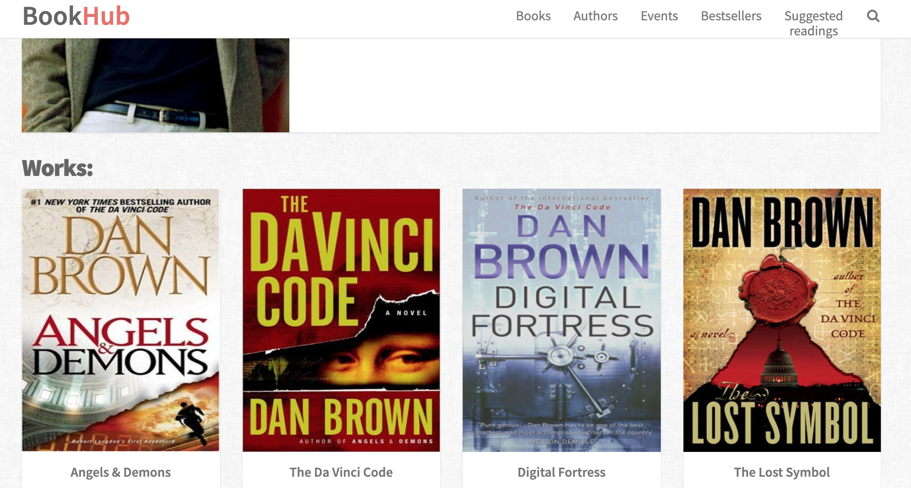

**Scenario 3:** Marco has just finished reading a book which he finds really interesting. He wants to find a characterized by the same genre. Thus, he decides to utilize BookHub to find similar books.  
He can either look on the book’s page and consider its related books or see all books with the same genre on the homepage with the right filter.

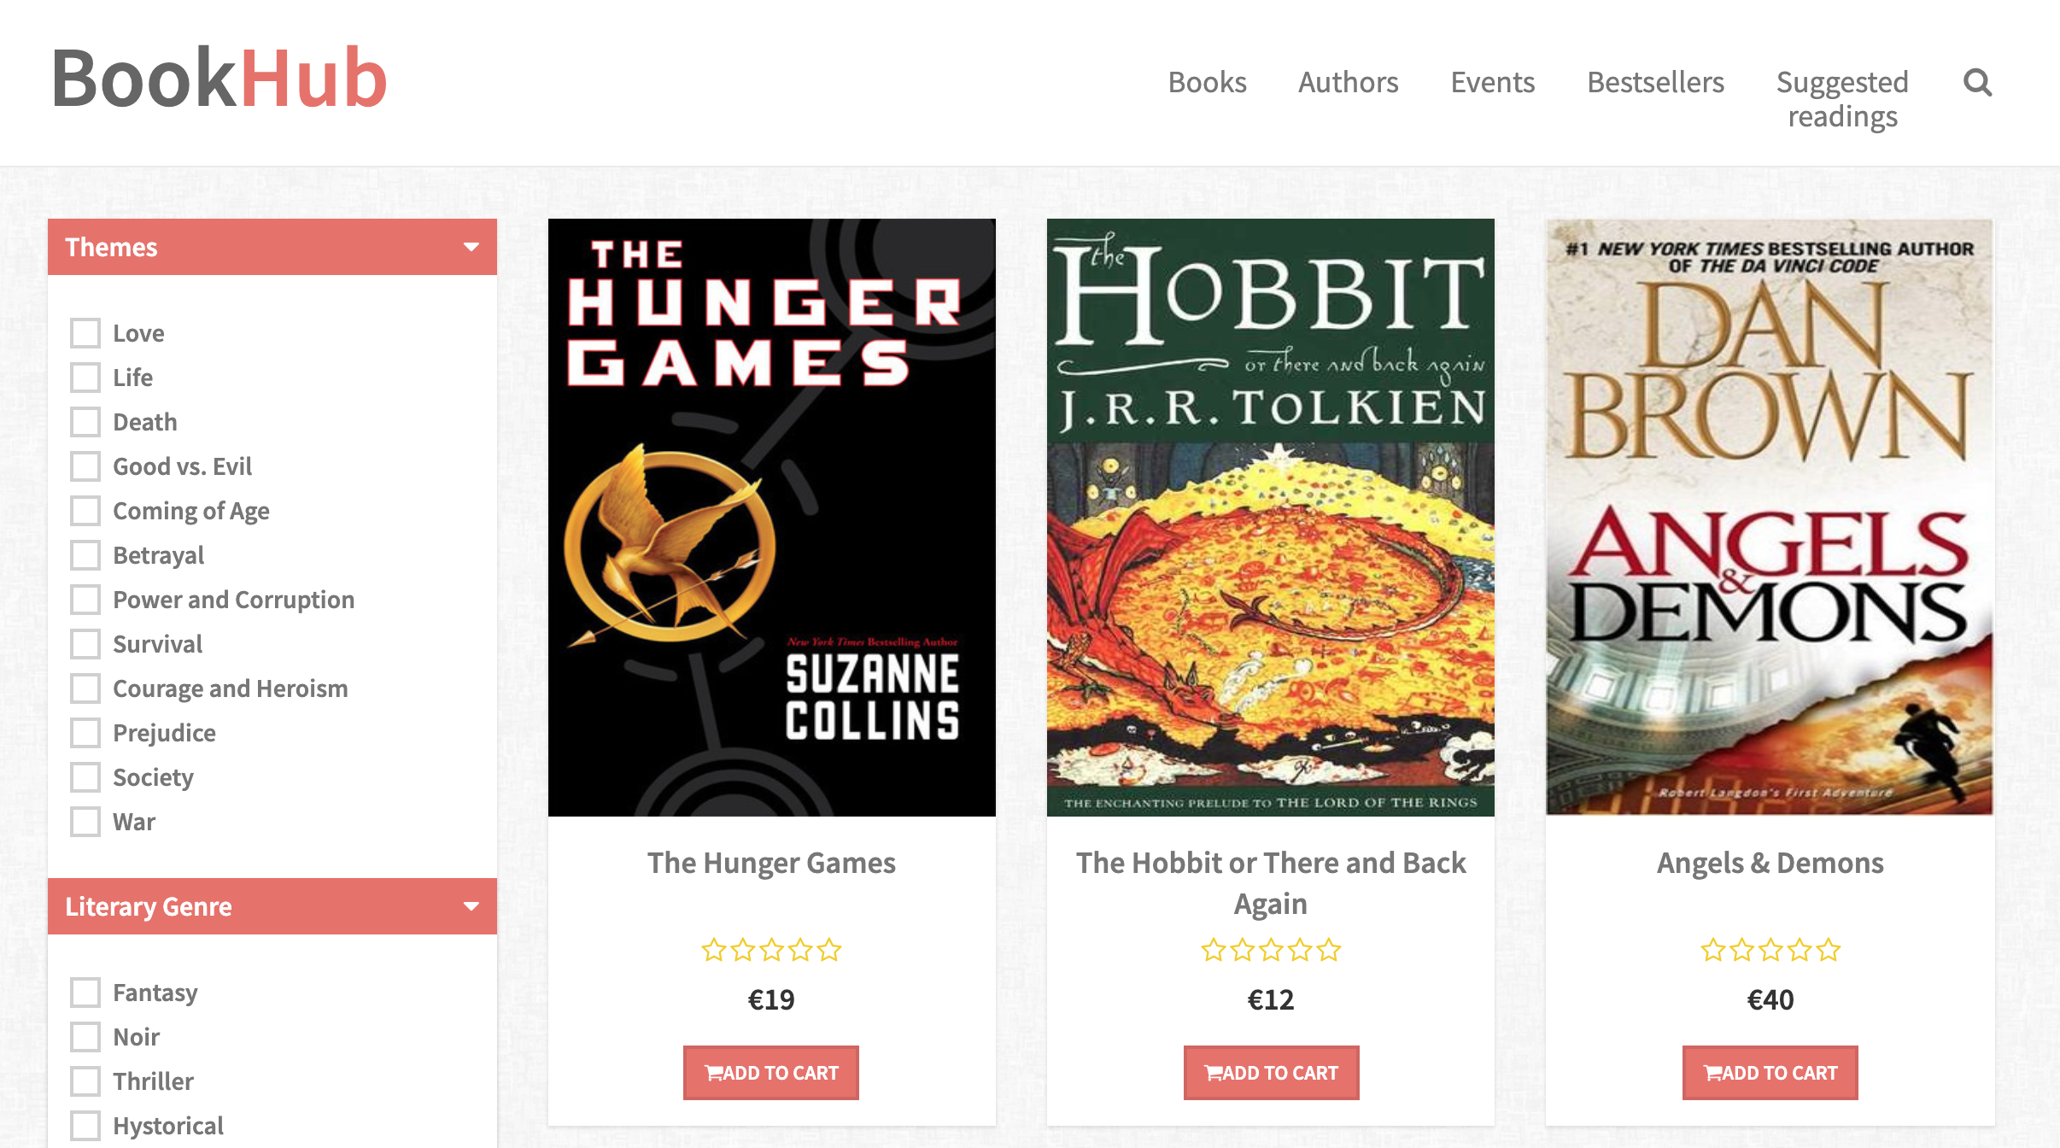

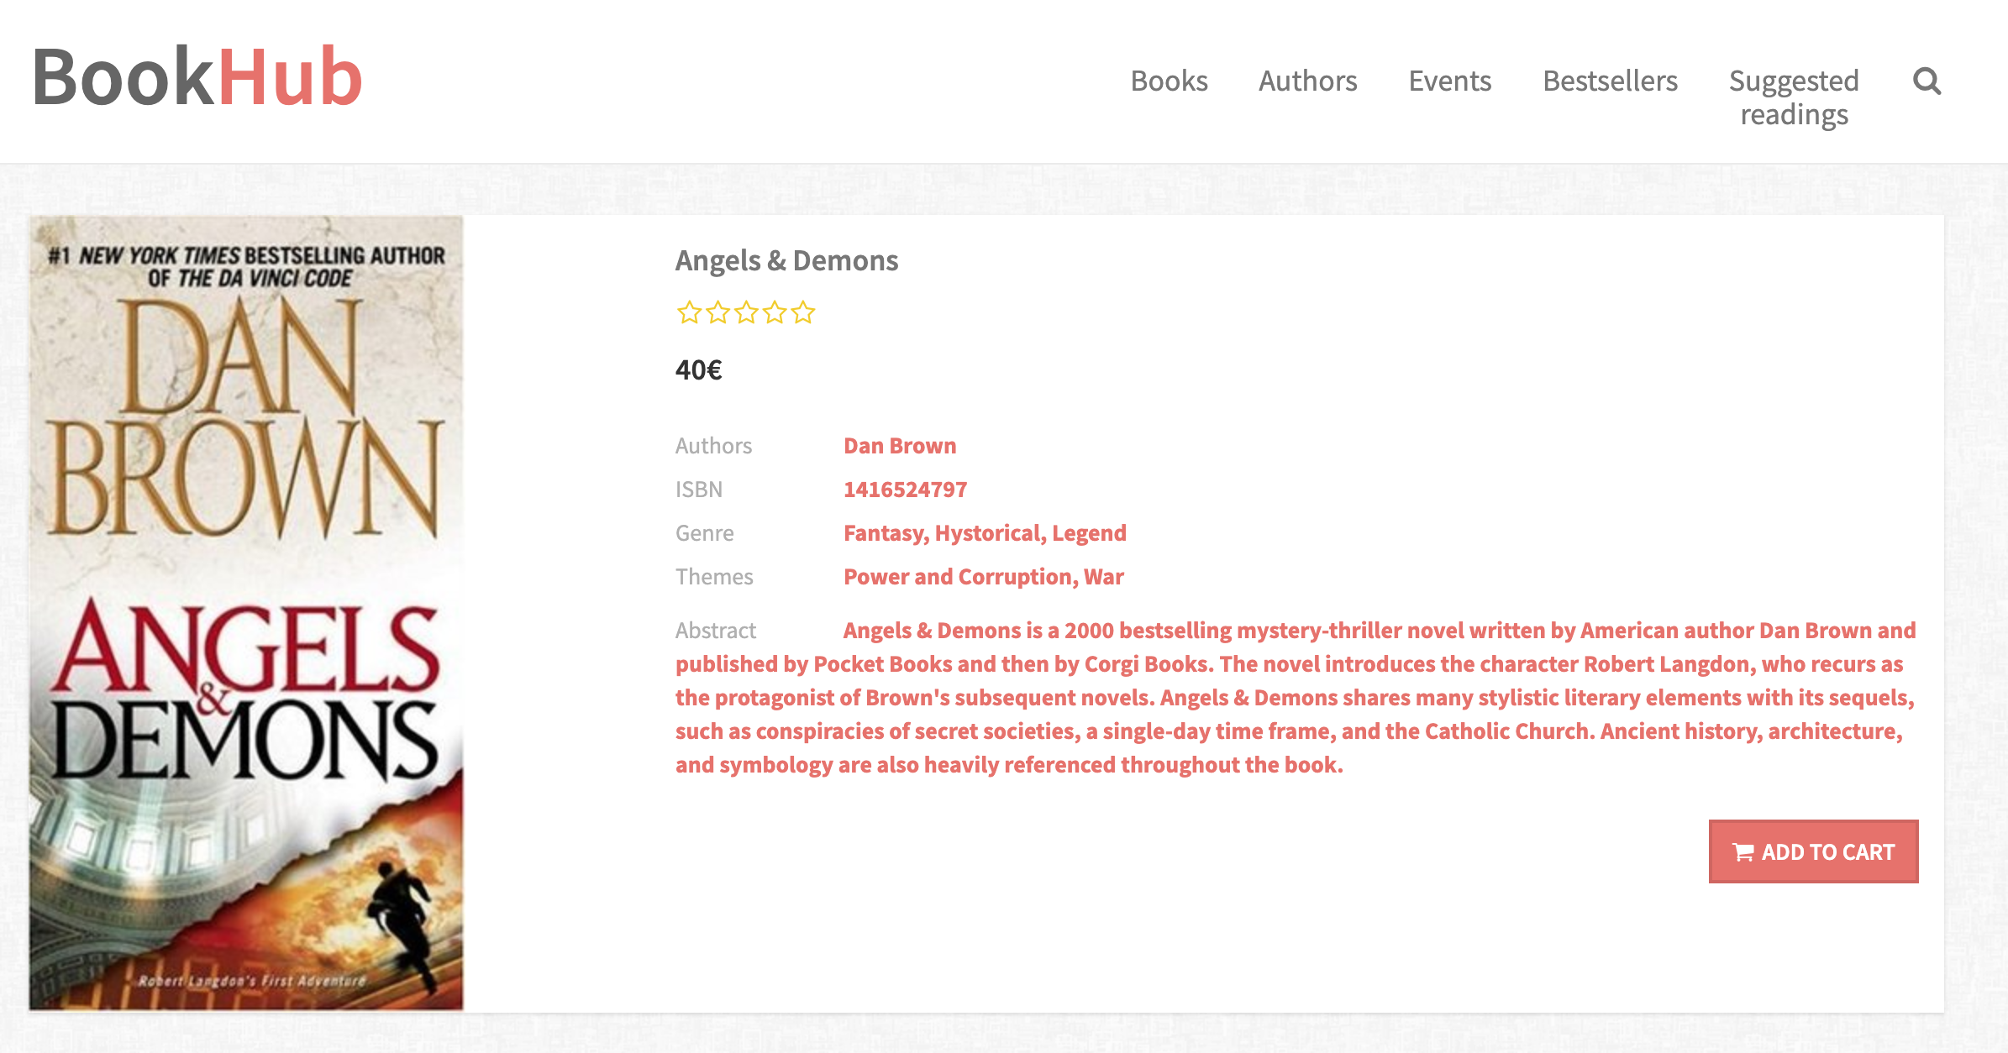

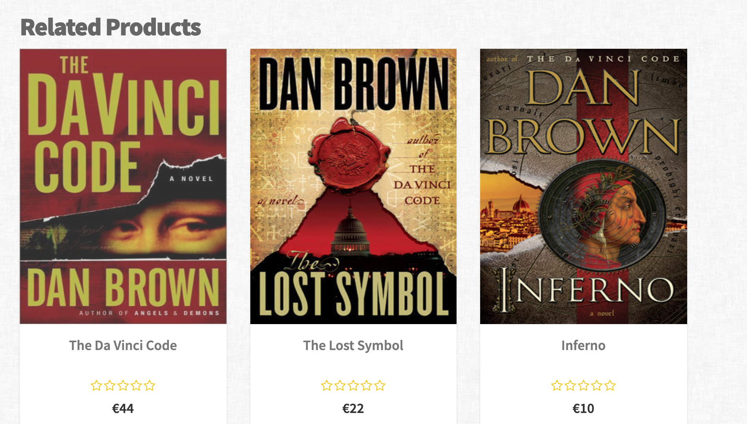

**Design in-the-small**

In order to specify correctly the requirements of our front-end prototype, in the design in-the-small phase of the assignment we have defined the basic visual organization of contents, navigation and interaction elements of our website.

In order to do so, we have created several **medium fidelity wireframes**, one for each page involved in our scenarios.

For almost all the pages of the website, we used the same basic structure, composed by:

1. an **header**;
2. the main content **body**;
3. a **footer**.

Header and footer contain the **landmarks** links, which direct to the main topic of our website, in particular:

* the **header** contains the clickable title that redirect to the homepage, landmarks links for all the website main pages, the cart and the search bar;
* the **footer** theinformationfor the **Contact us** and the landmark for the **FAQ** page.

The main content **body** instead, present content and transition links for the topic and multiple topic pages.

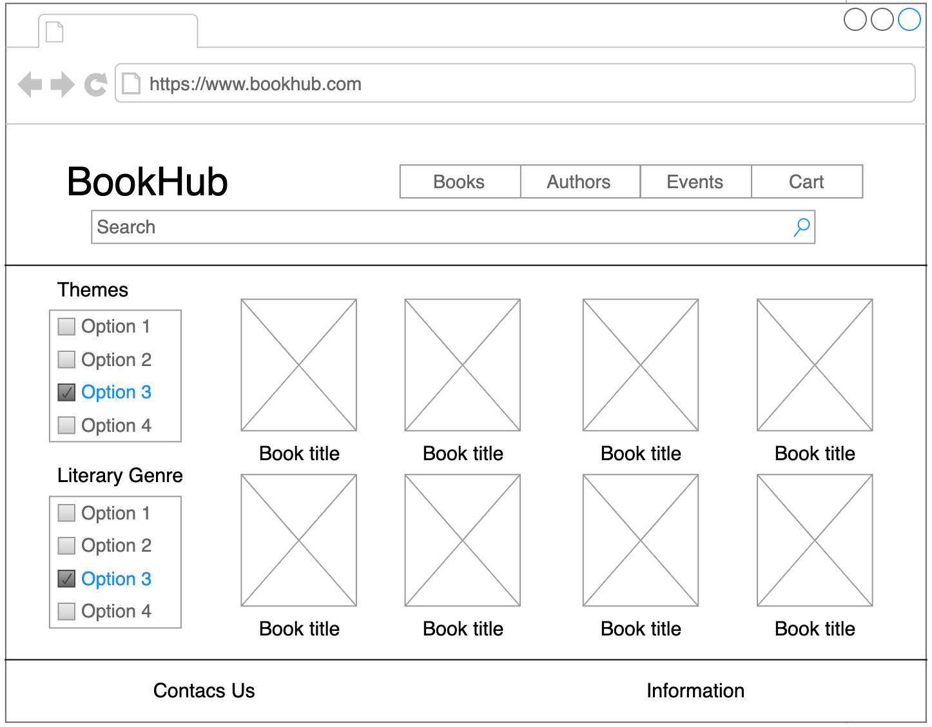

Figure 1 – Home Page (Book page)

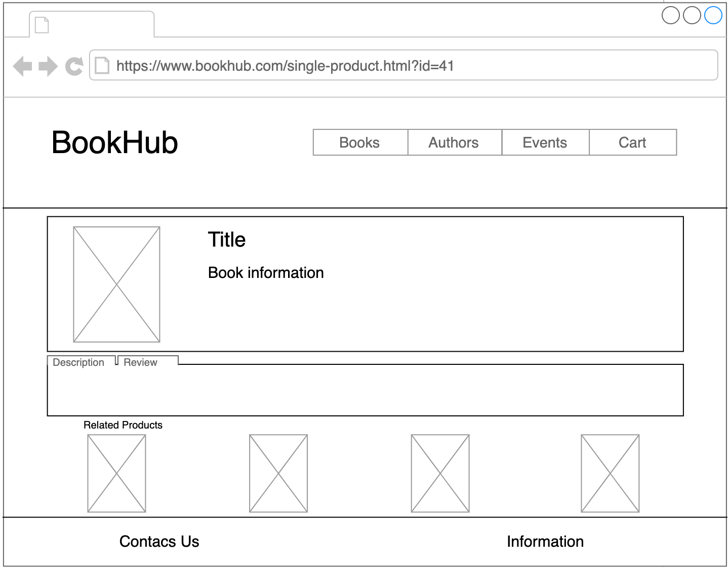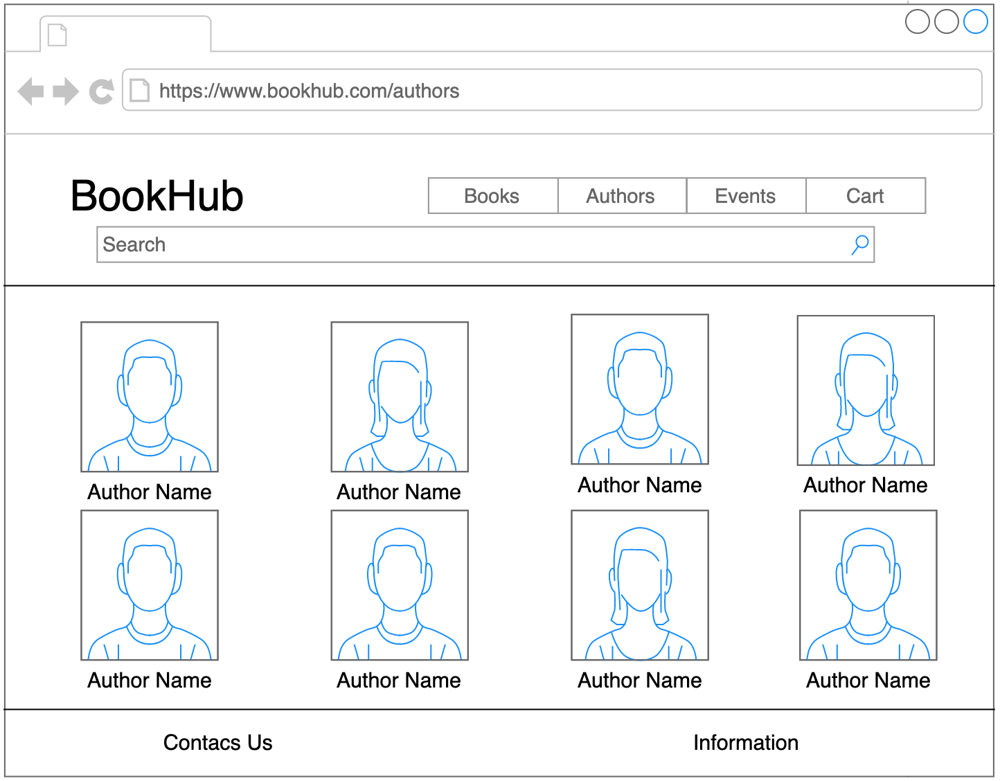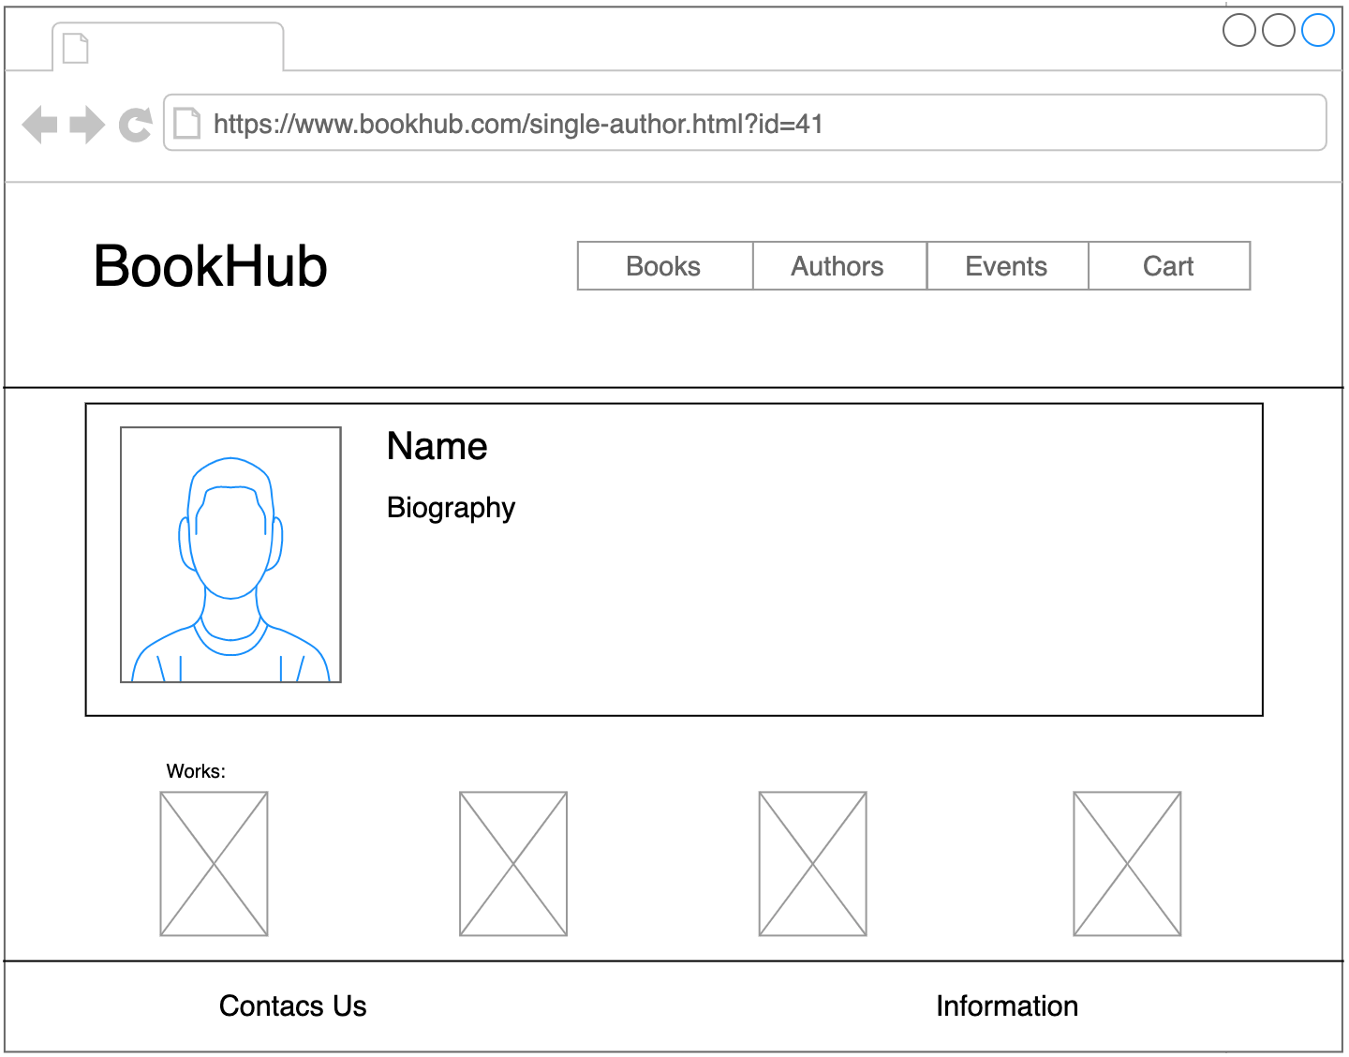

Figure 2 – Single Product page

Figure 3 – Author Page

Figure 4 – Single Author Page

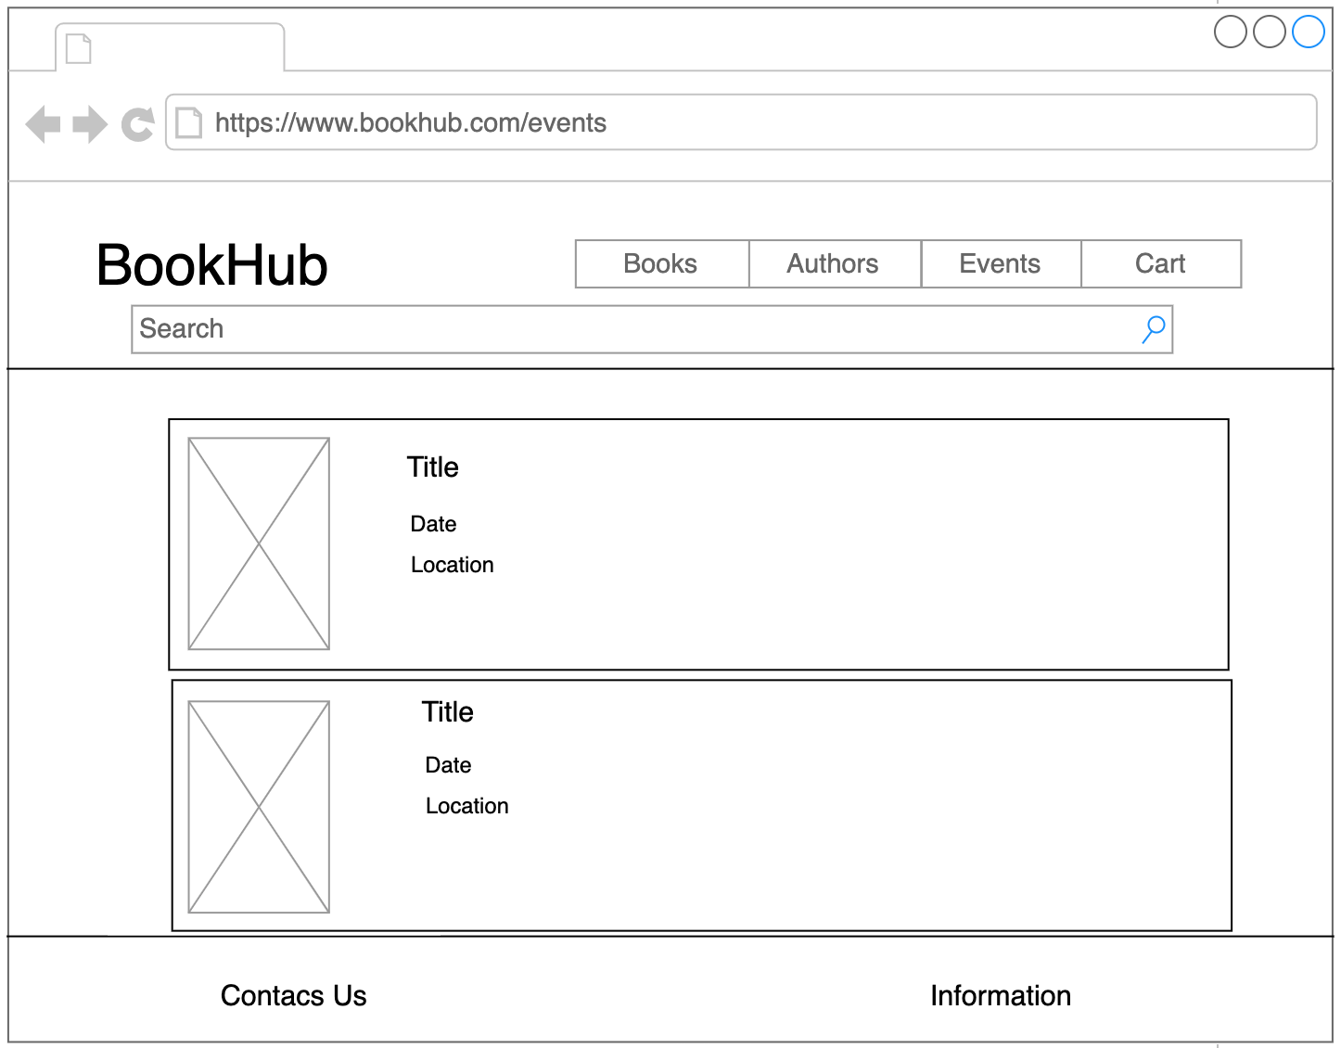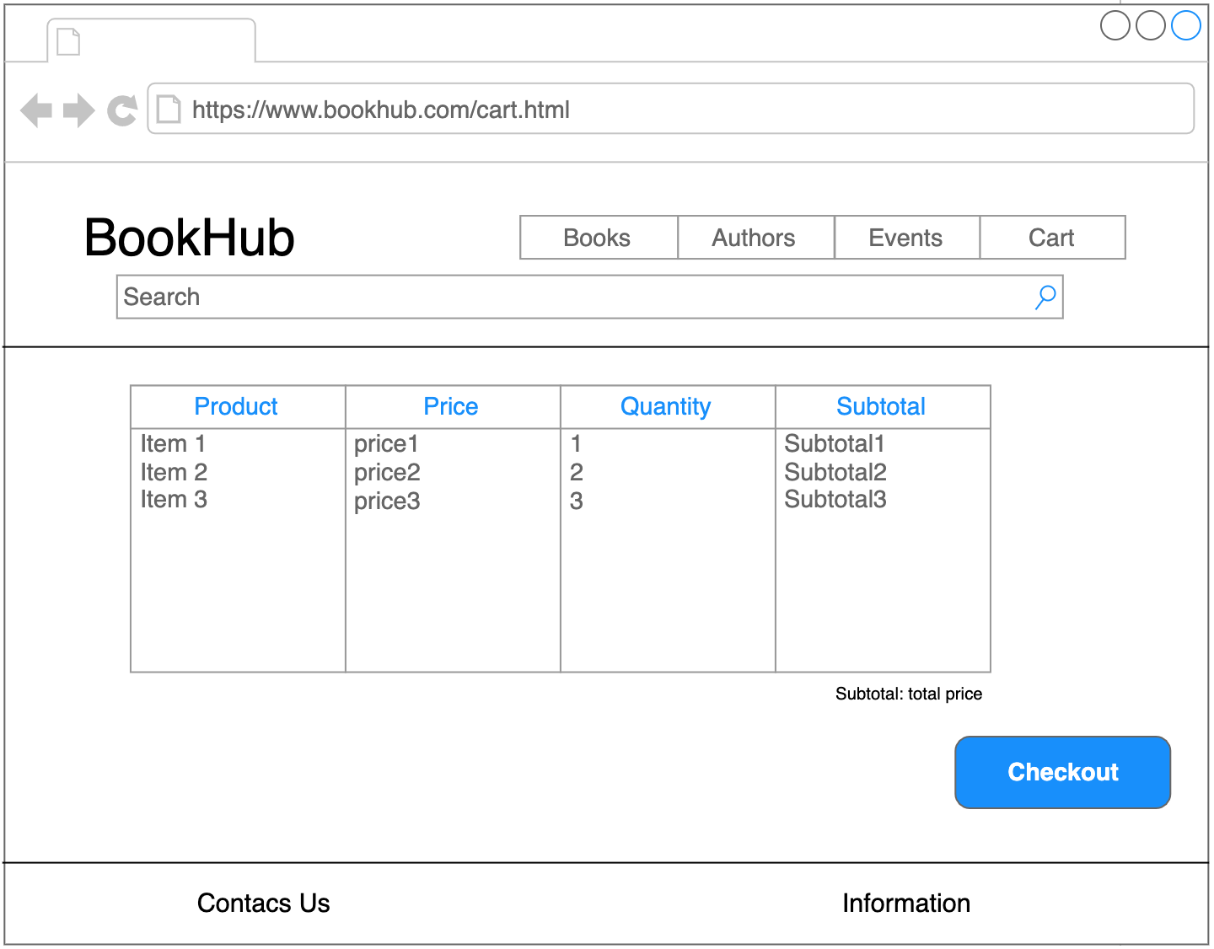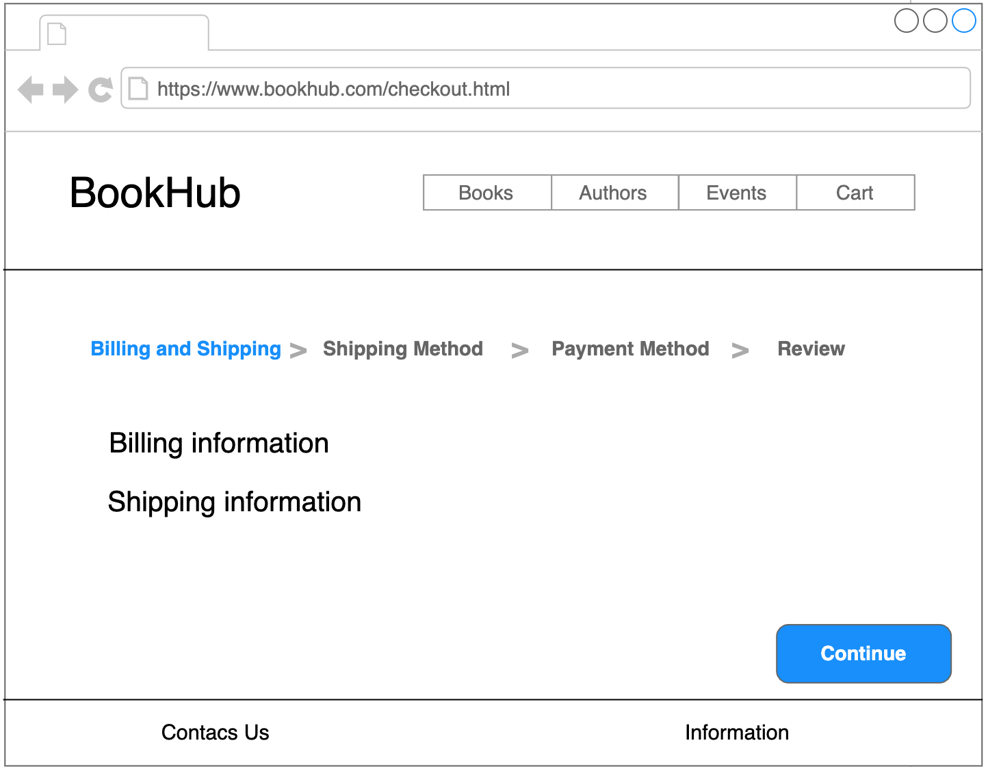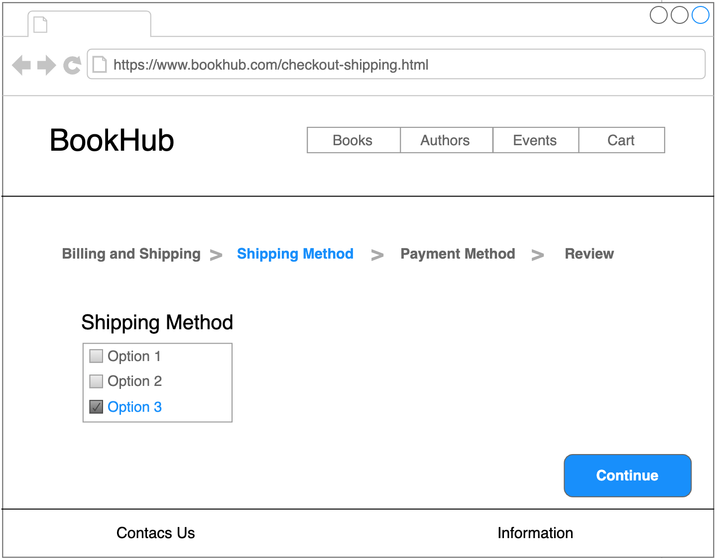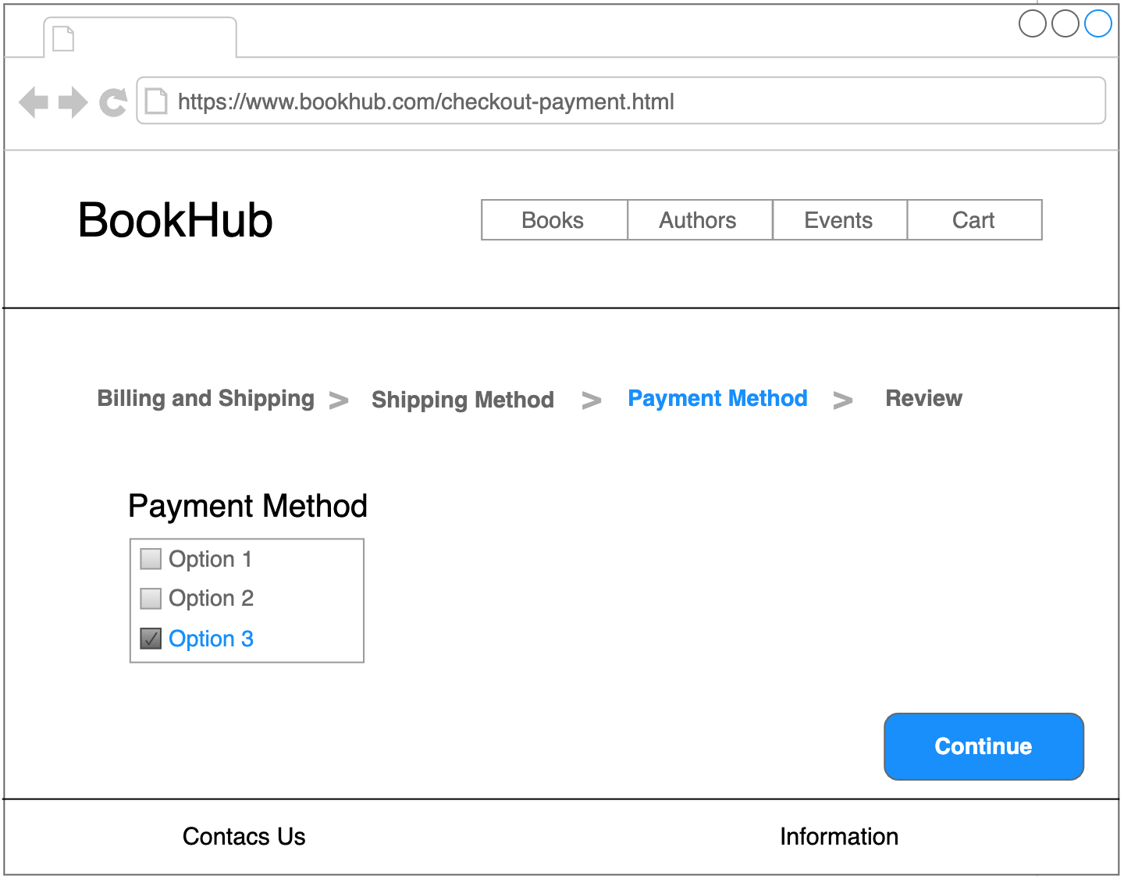

Figure 5 – Event Page

Figure 6 – Cart Page

Figure 7 – Checkout Page

Figure 8 – Checkout Shipping Method Page

Figure 9 – Checkout Payment Method Page

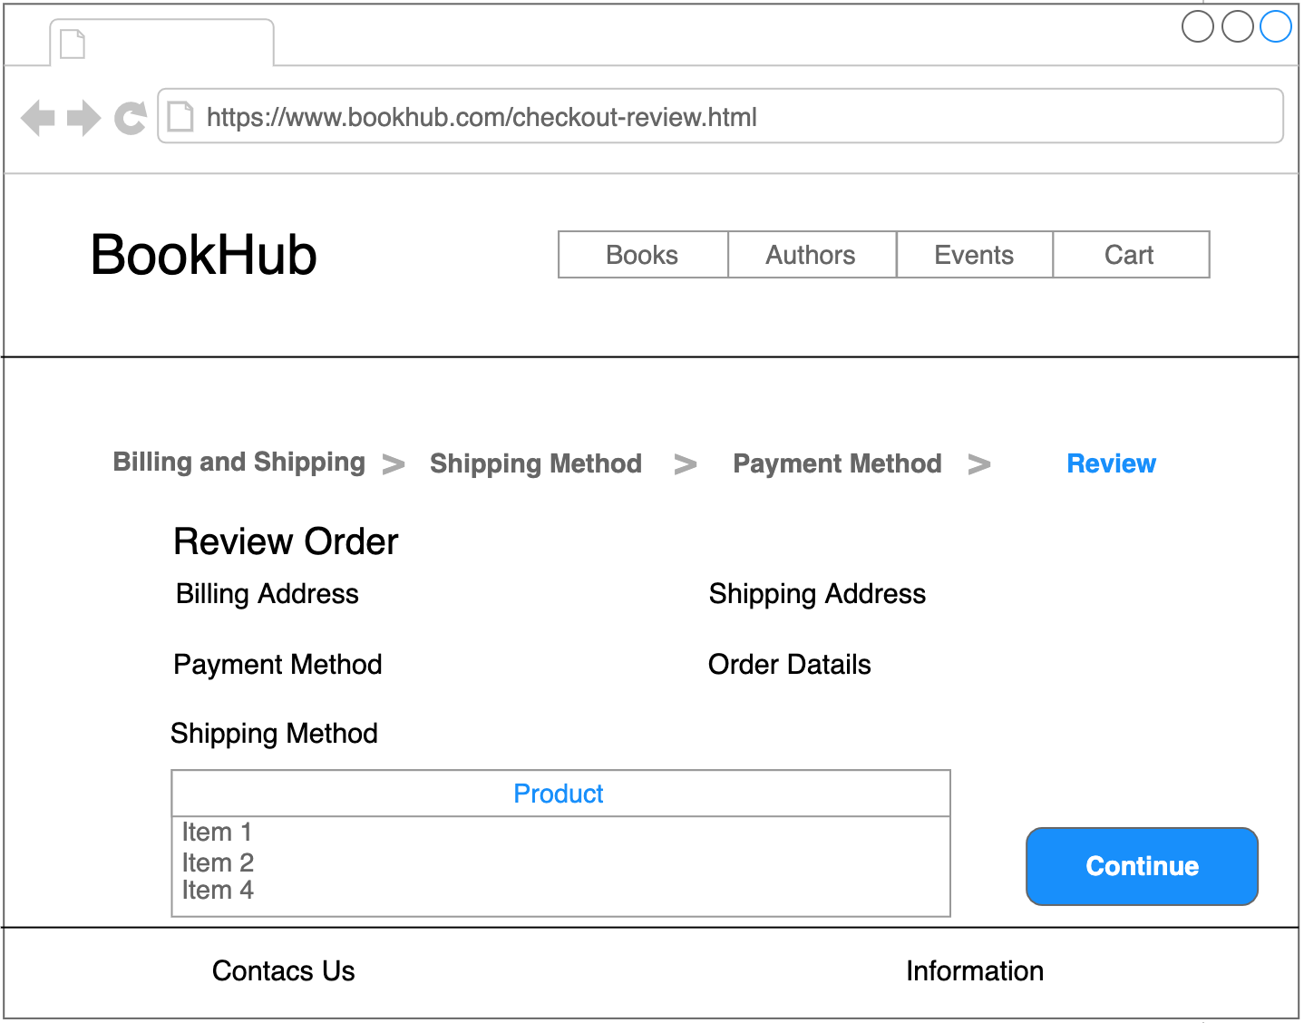

Figure 10 – Checkout Review Page

**Database Design**

In the **ER diagram** we have represented the main **entities**, along with their **attributes**, that we thought may be useful in the implementation of our application, and the **relations** between them.

The entities we have found are:

* **Author:** The author of a book
* **Event:** An event in which a book is presented
* **Book:** a book that a user can order through the website
* **Order:** an order executed by a user, contains various books
* **User:** a user registered to the web application
* **Address:** contains all the data of a specific address, used in many contexts of the website
* **Publisher:** the editor of a book
* **Review:** a review of a book that can be written by a user
* **Genre:** the genre of a book
* **Theme:** the theme of a book
* **Cart:** a temporary list of books that a User wishes to order

Here is the ER diagram, that highlights all the Entities, and the type and cardinality of relations existing among them:

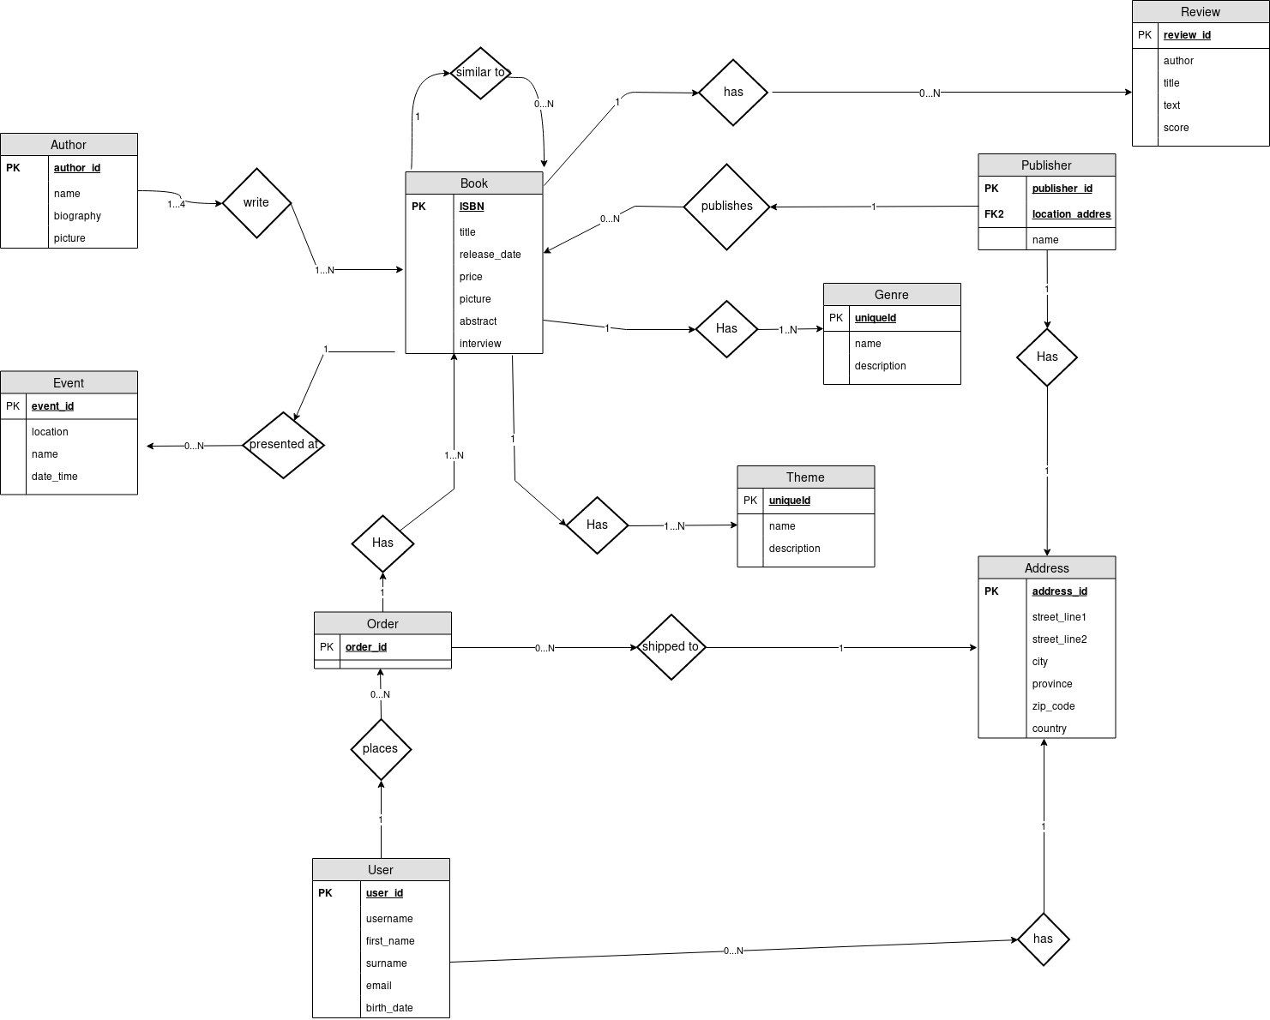

To represent the multiple relations shown above, we created in the database the following relations, with a little explanation on why we decided to do so:

* **Author_book:** many authors can write the same book
* **Book_genre:** a book may belong to more than one genre
* **Theme_genre:** a book may belong to more than one theme
* **Cart_book:** each cart has a list of more books, each one with a quantity
* **Similar_book:** a book may be similar to more than one book